**Creating a "no hypervisor" boot entry**

From time to time I want to run Virtual PC / Virtual Server on my Hyper-V system.  While I can do this with the hypervisor running, the result is that Virtual PC / Virtual Server run quite slowly.  An easy fix for this is to create a second boot entry for my system that starts Windows without starting the hypervisor.  To do this you need to open an administrative command prompt and run:

1. bcdedit /copy {current} /d "Microsoft Windows Server 2008 – no hypervisor"

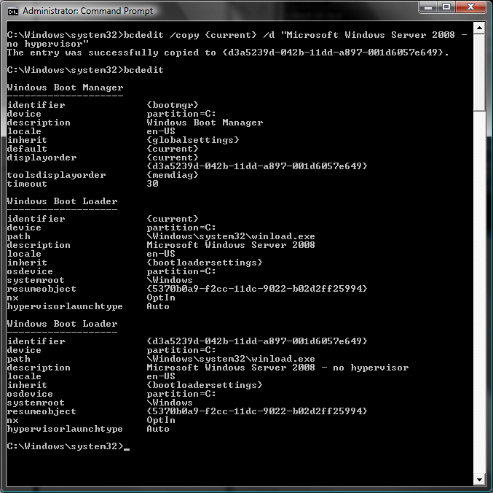

This copies your currently active boot entry (assuming that this is the one you want to copy) and gives the new copy an appropriate description.

1. bcdedit /set {*identifier for the new boot entry (copy from the output of a plain ‘bcdedit’ command)*} hypervisorlaunchtype off

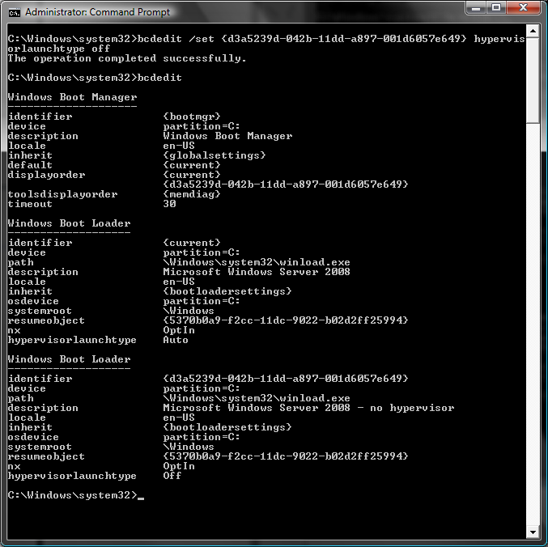

After doing this you can choose whether the hypervisor gets loaded whenever you boot the system.

Cheers,   
Ben